Special School Eye Care Service

ABOUT MY CHILD’S EYES

Child’s Full Name
School Name |  | Today’s Date

Introduction

This form will provide valuable information to the NHS England Special School Eye Care Team to ensure they can:

- make the eye test and dispensing of glasses (if required) a positive experience for your child
- understand what is already known about the eye health and vision of your child
- receive other information about your child that will help them provide the best possible service.

We will be asking questions in the following categories:

- Your Child’s Details / Your Details
- The Eye Test (Part 1)
- Eyecare History: Visits to the Optician / Visits to the Hospital
- Glasses
- Other Eye Information about your Child
- Other Health Information about your Child
- Eye Information about your Family
- The Eye Test (Part 2)
- 5 Key Questions

Completing the form
Not everything in this form will be relevant to your child but the more information you provide, the more we can tailor the service to your child’s specific needs.

Where answer options are provided, please click on to indicate your choice. You can click again to change your choice.

If you are completing the form electronically, the ‘free text’ boxes will expand to as much text as you type.

If you are completing the form by hand, please enlarge the text boxes to the size you require for your information before printing.

Returning the form
When completed, please return this to the school using the details on the Service Participation and Opt-Out form.

With much gratitude to SeeAbility for the content of this form
Your Child’s Details

Address & Postcode
Phone Number
Date of Birth
Ethnicity *
Name of Child’s GP
GP Practice Address
* Please see last page for options

Your Details

Full Name
Address & Postcode
Phone Number
Email Address
Relationship to Child

The Eye Test (Part 1)
See also Part 2

If any of the following are applicable, it would be useful for the Optometrist and Dispensing Optician to see these at the eye test:

- your child’s glasses
- the prescription from your child’s last eye test
- your child’s Education, Care and Health Plan or personal records

Would you like to attend your child’s first Eye Test at the school? | ☐ Yes ☐ No ☐ Don’t know
If Yes – please bring with you the three items mentioned above if available

If No – please arrange for the school to have these prior to the appointment if available
I am happy for the Optometrist to put drops in my child’s eyes.  ☐ Yes ☐ No  ☐ I would like to speak to the Optometrist first  These drops, also known as Cyclopentolate, help the Optometrist to see into the eye through the pupil. They may sting a little and vision may be blurry for a short time. Side effects are extremely rare. | 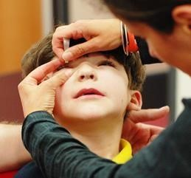

Eyecare History: Visits to the Optician

Has your child ever had an eye test at the Optician/Optometrist? | ☐ Yes ☐ No ☐ Don’t know  If No/Don’t Know, go to next section
If yes, Name and address of current Optician/Optometrist?
Date of last check
Date of next check
Can the Eye Care Team contact the Optometrist to access your child’s eye history?  Access to previous records can help the Eye Care Team provide a better service for your child | ☐ Yes ☐ No

Eyecare History: Visits to the Hospital

Has your child ever been to the Eye Clinic in a Hospital? | ☐ Yes ☐ No ☐ Don’t know  If No/Don’t Know, go to next section
If yes, what was the problem?
Name of the Hospital visited
Date of last appointment
Date of next appointment
Did your child have an operation on their eyes? | ☐ Yes ☐ No ☐ Don’t know
Can the Eye Care Team contact the Hospital to access your child’s eye history?  Access to previous records can help the Eye Care Team provide a better service for your child | ☐ Yes ☐ No ☐ Don’t know

Glasses

Has your child been prescribed glasses either by an Optician or from the Eye Clinic at a hospital? | ☐ Yes ☐ No ☐ Don’t know  If No/Don’t Know, go to next section
Has your child been given a patch for their glasses? | ☐ Yes ☐ No ☐ Don’t know
Is your child using their glasses now? | ☐ Yes ☐ No ☐ Don’t know
Does your child have any problems with their glasses? | ☐ Yes ☐ No ☐ Don’t know
If yes, please describe

Other Eye Information about your Child

Is your child registered blind / severely sight impaired? | ☐ Yes ☐ No ☐ Don’t know
Is your child registered partially blind / severely sight impaired? | ☐ Yes ☐ No ☐ Don’t know
Do your child’s eyes always appear straight? | ☐ Yes ☐ No ☐ Sometimes  ☐ Don’t know
If one or both eyes appear to wander, which eye does this?  How often does this happen? | ☐ Right eye ☐ Left eye  ☐ Both eyes ☐ Not applicable  ______________________________
Do your child’s eyes appear to move excessively rapidly or uncontrollably? | ☐ Yes ☐ No ☐ Don’t know
Do you think your child has trouble controlling their eye movements? | ☐ Yes ☐ No ☐ Don’t know
If yes, please give details:
Does your child tend to shut one eye? | ☐ Yes ☐ No ☐ Don’t know
Does your child appear very sensitive to bright lights? | ☐ Yes ☐ No ☐ Don’t know
Does your child complain of headaches? | ☐ Yes ☐ No ☐ Don’t know
Do you generally have concerns about your child’s eyes? | ☐ Yes ☐ No ☐ Don’t know
If yes, please describe:

Other Health Information about Your Child

Does your child use a wheelchair? | ☐ Yes ☐ No ☐ Don’t know
Does your child have any health problems or disabilities? | ☐ Yes ☐ No ☐ Don’t know
If yes, please describe them:
Does your child take any medication? | ☐ Yes ☐ No ☐ Don’t know
If yes, please list them: (please take information about the medication to the eye test)
Does your child have any allergies? | ☐ Yes ☐ No ☐ Don’t know
If yes, please list them:
Please give details of any difficulties during the pregnancy or child’s birth:

(eg. mother had infection, prematurity, low birth weight, need for special care, etc)

Eye Information about your Family

Has anyone in your family had eye problems? | ☐ Yes ☐ No ☐ Don’t know
For example, did anyone wear glasses as a child, had a squint (strabismus), a patch over an eye, or an eye condition?
If yes, please describe which family member in relation to yourself had the problem and what the problem was?
WHO | WHAT PROBLEM

The Eye Test (Part 2)

When your child has their eye test, the Optometrist will need to:

- look at their eyes
- do some tests to check how well they can see

The information you give below will help the Optometrist to test your child’s eyes and communicate with them effectively.

Will your child be alright if the Optometrist comes close to them and shines a bright light in their eyes?  This is done with an instrument called a Retinoscope.  ☐ Yes ☐ No ☐ Don’t know? | 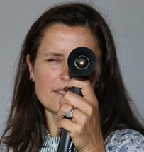
Will your child be alright if the Optometrist was to cover their eyes one at a time? | ☐ Yes ☐ No ☐ Don’t know
Can your child understand better or worse?  ☐ Yes ☐ No ☐ Don’t know? | 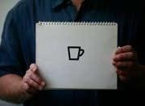  Better Worse
Will your child be able to wear test frames on their face?  ☐ Yes ☐ No ☐ Don’t know | 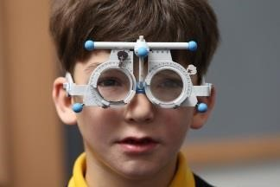
Can your child say or sign the names of letters on any Eye Test Chart?  ☐ Yes ☐ No ☐ Don’t know | 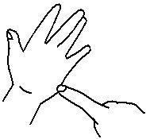  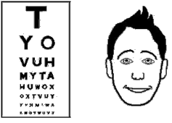
Can your child say or sign the names of pictures on a chart (like house, fish, car)?  ☐ Yes ☐ No ☐ Don’t know | 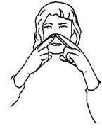  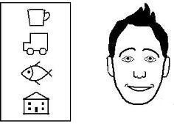
Can your child point to a letter or picture on a card that is the same letter or picture on a chart on the wall?  ☐ Yes ☐ No ☐ Don’t know | 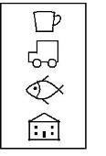  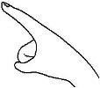  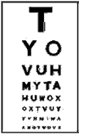
Is your child deaf or hard of hearing? | ☐ Yes ☐ No ☐ Don’t know
If yes, please give more detail
Does your child find it hard to communicate? | ☐ Yes ☐ No ☐ Sometimes
Please indicate if your child uses any of the methods below to communicate and describe any other ways you might communicate with your child if appropriate?
Makaton ☐ Yes ☐ No  An interpreter ☐ Yes ☐ No  Pictures ☐ Yes ☐ No  Gestures ☐ Yes ☐ No | Other ways:

5 Key Questions

These questions may not be applicable to your child but are used to help us identify if they might have problems with their vision that are due to their brain rather than their eyes (known as CVI – cerebral visual impairment).

1 Does your child have difficulty walking down stairs?

☐ ☐ ☐ ☐ ☐ ☐
Never Rarely Sometimes Often Always Not applicable
2 Does your child have difficulty seeing fast-moving objects?

☐ ☐ ☐ ☐ ☐ ☐
Never Rarely Sometimes Often Always Not applicable
3 Does your child have difficulty seeing something that is pointed out in the distance?

☐ ☐ ☐ ☐ ☐ ☐
Never Rarely Sometimes Often Always Not applicable
4 Does your child have difficulty locating an item of clothing in a pile of clothes?
☐ ☐ ☐ ☐ ☐ ☐
Never Rarely Sometimes Often Always Not applicable
5 Does your child find copying words or pictures time-consuming and difficult?

☐ ☐ ☐ ☐ ☐ ☐
Never Rarely Sometimes Often Always Not applicable

Finally, is there any other information about your child the Optometrist may need to know?

Thank you very much for detailing as much information as possible.

This will help the visiting Eye Care Team to provide the
best eye care possible for your child.

Ethnicity options

This information allow the NHS to measure and improve access, experiences and health outcomes for all patients from all communities. Please choose one to fill in the ethnicity box.

White
English, Welsh, Scottish, Northern Irish or British
Irish
Gypsy or Irish Traveller
Any other White background

Mixed or Multiple ethnic groups
White and Black Caribbean
White and Black African
White and Asian
Any other Mixed or Multiple ethnic background

Black, African, Caribbean or Black British
African
Caribbean
Any other Black, African or Caribbean background

Asian or Asian British
Indian
Pakistani
Bangladeshi
Chinese
Any other Asian background

Other ethnic group
Arab
Any other ethnic group

Sourced from Gov.UK 2021

