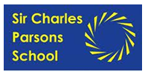

Sixth Form Uniform
This Sixth Form dress code is designed to look professional, corporate and smart. The Sixth Form are seen as positive role models to the rest of the school. No student should have hair that is dyed any colour that does not look natural and no visual tattoos. Support from home with this is essential.
The following uniform is compulsory in the sixth form:
Smart Black trousers (NO BLACK JEANS OR CROPPED TROUSERS)
BOYS: Plain black shirt (tucked in) GIRLS: Plain black or white blouse
Smart black shoes
Sixth Form tie/scarf (Sixth Form ties/scarves will be distributed for free on the first day of term)
If you have forgotten your tie or scarf one can be borrowed from the Sixth Form office. Replacement scarves and ties are £6.00
Optional uniform includes:
Black cardigan, jumper or smart jacket
PE Kit
Plain white or black t-shirt
Blue or black shorts or track suit bottoms and jumper

Hair styles
Hair styles must be simple and ordinary and any hair colouring must look natural.
The College does not permit hairstyles that reflect the extremes of fashion – unnatural or extravagant colouring, extensions, beads or designs cut into the hair, flowers or headbands are not permitted.
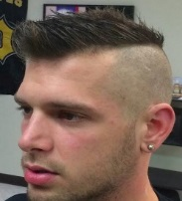
Boys’ hair must NOT be cut on any less than a number 1, which has been graded. No lines or patterns are permitted. This hair has been shaved with a guard less than 1 and has not been graded, therefore is not permitted.
ID badges will be issued in September and MUST be worn at all times. If lost replacements cost £5.00

