

***Year 12 Staff***

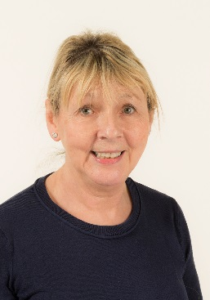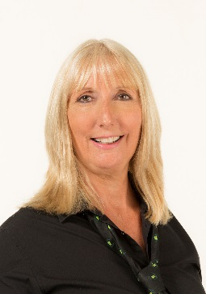

**Adela Loraine (SCP)**

**Year 12 Teacher**

**Ann Casson (SCP)**

**Learning Support Assistant**

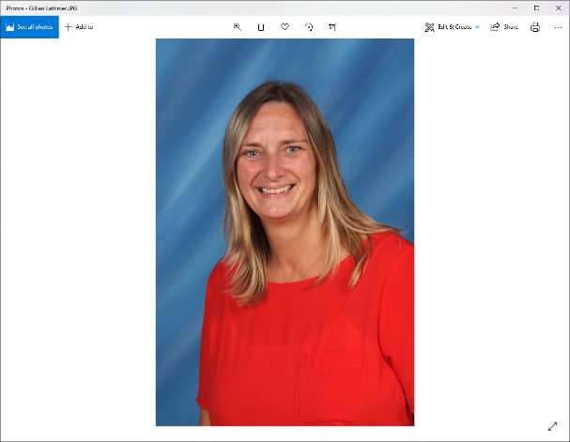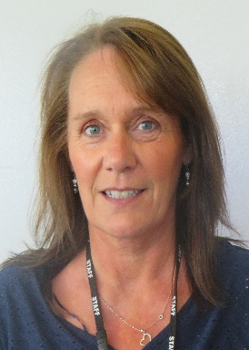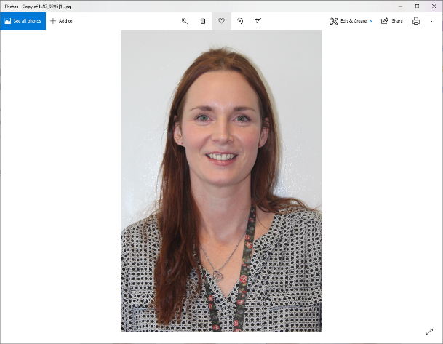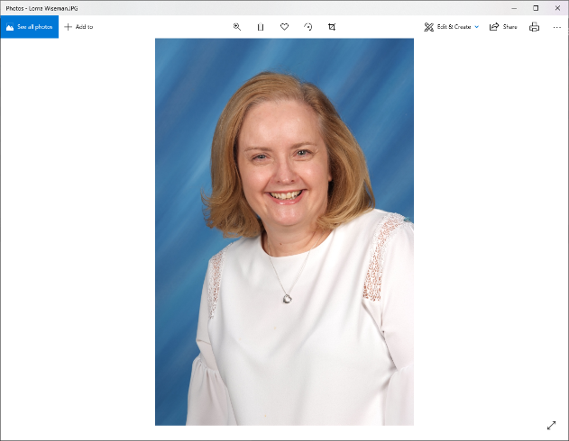***Year*** *13 and 14 Staff*

**Gillian Lattimer (WRA)**

**Senior Learning Support Assistant**

**Tracy Brown (SCP)**

**Learning Support Assistant**

**Lisa Simpson (WRA)**

**Senior Learning Support Assistant Teacher**

**Lorna Wiseman (WRA)**

**Year 13 & 14 Teacher**



**Year 12 mobile contact number 07771371634.**

**Year 13 and 14 mobile contact number 07917071255.**

**Walker Riverside Academy switchboard 0191 2958660.**

**Sir Charles Parsons switchboard 0191 2952280.**





**Year 12 mobile contact number 07771371634.**

**Year 13 and 14 mobile contact number 07917071255.**

**Walker Riverside Academy switchboard 0191 2958660.**

**Sir Charles Parsons switchboard 0191 2952280.**