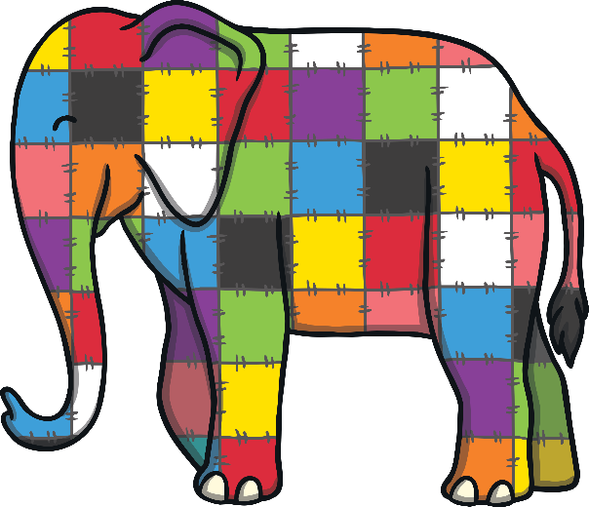

Elmer

‘Can You Find…?’ Poster Instructions

Can you find these things in the picture?

crocodile

monkey

fat elephant

Elmer

baby elephant

tiger

hippo

snake

tall elephant
Which of the animals have jungle stripes?
Which animal is the biggest?
Which of these animals might like to cool off in the water?
Why is Elmer different to all the other elephants?
How do you think Elmer feels about being different?
What are your favourite colours?
Would you like to be colourful like Elmer or grey like the other elephants? Why?
